MARIA MITCHELL CHAPTER
2154VA DISTRICT V

NATIONAL SOCIETY
DAUGHTERS
OF THE
AMERICAN REVOLUTION
(NSDAR)

Tysons Corner, VA
2016-2017 Yearbook

Organized July 2015 By Michelle Caputy
Daughters of the American Revolution
Maria Mitchell Chapter
Maria Mitchell was born on August 1, 1818, and died June 28, 1889; she grew up in Massachusetts where her father was the principal of the local school. He encouraged equality especially intellectual equality between men and women. He encouraged Maria’s passion in astronomy, when she was 12 years old they calculated the exact moment of an annual eclipse.
In adulthood, Maria worked as the librarian of the Nantucket Athenaeum, where she was able to study mathematics, navigation and astronomy. In the evenings she would look at the night sky with a telescope and in 1947, she discovered a new comet-- “Miss Mitchell’s Comet." For this discovery she was awarded a gold medal from the King of Denmark. Maria gained international attention for her work in astronomy; some of her accolades include she was the first woman elected as a Fellow of the American Academy of Arts and Sciences, the American Association for the Advancement of Science and the American Philosophical Society. In 1865 she became the first professor of astronomy at Vassar College; here she fought for a salary comparable to her male counterparts and promoted women through the foundation of the Association for the Advancement of Women (AAW)[1].
This new DAR chapter of young professional women strives to embody her passion for education and career.

MOTTO
The most dangerous phrase in language is “we’ve always done it this way.”
- Grace Hopper

FLOWER

A ZINNIA – THE FIRST FLOWER GROWN IN SPACE

COLORS

GRACE HOPPER
MICROSECOND
GOLD – THE COLOR OF GRACE HOPPER’S MICROSECOND
NANOSECOND
SILVER – THE COLOR OF GRACE HOPPER’S NANOSECOND

OPENING RITUAL
CHAPLAIN: Opening Prayer

REGENT: To perpetuate the memory and spirit of the men and women who achieved American Independence; to promote an enlightened public opinion; and to foster true patriotism and love of country. These are the objects of our National Society, Daughters of the American Revolution.

CHAPLAIN:"...keep that which is committed to thy trust..."
(1 Timothy 6:20)

RESPONSE:"...YEA, I HAVE A GOODLY HERITAGE."
(Psalm 16:6)

CHAPLAIN:"...thou shalt remember all the way which the Lord thy God led thee..."
(Deuteronomy 8:2)

RESPONSE:"...BLESSED IS THE NATION WHOSE GOD IS THE LORD..."
(Psalm 33:12)

THE PLEDGE OF ALLEGIANCE TO THE FLAG OF
THE UNITED STATES OF AMERICA
(in unison)
I pledge allegiance to the Flag of the United States of America and to the Republic for which it stands, one Nation under God, indivisible, with liberty and justice for all.
Francis Bellamy

THE AMERICAN'S CREED

(in unison)
I believe in the United States of America as a government of the people, by the people, for the people; whose just powers are derived from the consent of the governed, a democracy in a republic, a sovereign Nation of many sovereign States; a perfect union, one and inseparable, established upon those principles of freedom, equality, justice, and humanity for which American patriots sacrificed their lives and fortunes.
I therefore believe it is my duty to my country to love it, to support its Constitution, to obey its laws, to respect its flag and to defend it against all enemies.
William Tyler Page

CHARTER MEMBERS

TBD

CHAPTER REGENTS

Grace Fischetti | 2017-Current
Michelle Caputy | 2015-2017

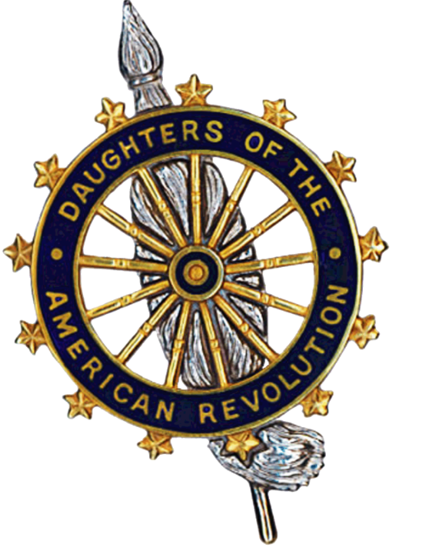
THE FOUR FOUNDERS
1890
Mary Desha, Mary S. Lockwood, Ellen Walworth, Eugenia Washington
"GOD, HOME AND COUNTRY"

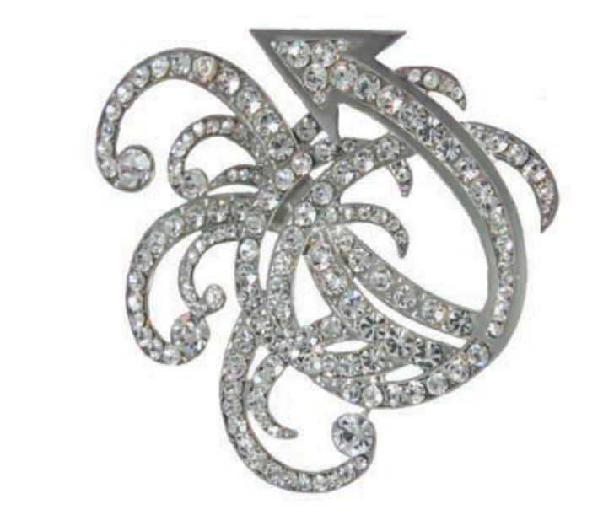
PRESIDENT GENERAL
2016-2019
Ann Turner Dillon
"Moving Forward in Service to America"


VIRGINIA STATE REGENT
2016-2019
Judith “Judy” Joy Surber
“We the Daughters, many hands, strive to preserve the history…share the knowledge…and thoroughly enjoy the Blessings of Liberty.”

VIRGINIA DISTRICT V DIRECTOR
2016-2019
Wanda English

2016-17 GENERAL INFORMATION:

LEVEL | ADDRESS | USERNAME/PASSWORD
NATIONAL | DAR.org/members | name,  chapter, and national number
STATE | VADAR.org/membersonly | USConstitution
DISTRICT | VADARdistrict5.org | USConstitution
CHAPTER | Mariamitchellchapt.wixsite.com/maria-mitchell | ___

2016-17 LEADERSHIP INFORMATION:

LEVEL | NAME | ADDRESS
NATIONAL | NSDAR HEADQUATERS | Administration Building  1776 D Street NW  Washington, DC 20006-5303  202-628-1776
STATE | Judy Surber | stateregent@vadar.org
DISTRICT | Wanda English | wandaenglish@earthlink.net
CHAPTER | Grace Fischetti | mariamitchellchapterdar@gmail.com

2016-17 POSITIONS HELD BY CHAPTER MEMBERS

LEVEL | TYPE | TITLE | MEMBER
NATIONAL | Commemorative Events | National Vice Chair | Michelle Caputy Reynolds
 | DAR Museum Outreach | State Chair | Ann Wiley Moser
STATE | ___ | ___ | ___
DISTRICT | ___ | ___ | ___
CHAPTER | OFFICER | REGENT | Grace Rosina Fischetti
 |  | FIRST VICE REGENT | Martina Elizabeth Caputy
 |  | SECOND VICE REGENT | ___
 |  | CHAPLIN | Sarah Michelle Corey
 |  | RECORDING SECRETARY | Ann Wiley Moser
 |  | CORRESPONDING SECRETARY | Linda Friauf Fischetti
 |  | TREASURER | Cynthia Ann Willuweit Kaiser
 |  | ASSISTANT TREASURER | ___
 |  | RESIGTRAR | Melissa Keller Schwolow Riesco
 |  | ASSISTANT REGISTRAR | ___
 |  | HISTORIAN | Courtney Elizabeth Clark Dozier
 |  | LIBRARIAN | Laura Anne Lieberman

2016-17 POSITIONS HELD BY CHAPTER MEMBERS CONTINUED

LEVEL | TYPE | TITLE | MEMBER
CHAPTER | COMMITTEE CHAIRMAN | American History | Courtney Dozier
 |  | AMERICANISM AND DAR MANUAL  FOR CITIZENSHIP | Amanda White
 |  | Children of the American | Ana Cristina Gibbons
 |  | Commemorative Events | Grace Fischetti
 |  | Community Service Awards | Michelle Caputy
 |  | DAR Schools | Rachelle Millard Janke
 |  | DAR Service for Veterans | Michelle Caputy
 |  | Dar Museum | Melissa Riesco
 |  | DAR Project Patriot | Kelley Cappellini
 |  | Insignia | Christine Lathrop
 |  | Junior American Citizens | Alison Pisasale
 |  | Junior Membership | Grace Fischetti
 |  | Lineage Research | Ann Moser
 |  | Women's Issues | Michelle Maryfield
 |  | Conservation | Christine Lathrop
 |  | Scholarship | Melissa Riesco

2016-17 COMMITTEES WITH CHAPTER INVOLVMENT:

LEVEL | DESCRIPTION | MEMBER
National | Property Beautification and Hospitality | Martina Caputy
 |  | Michelle Caputy
 |  | Ann Moser
 |  | Melissa Keller Schwolow Riesco

2016-17 SERVICE PROJECTS WITH CHAPTER INVOLVEMENT:

LEVEL | CAUSE | ACCEPTED CONTRIBUTIONS
NATIONAL | Tamasse DAR School | Box tops and books
 | Wreaths across America | Wreath Laying

2016-2017 EVENTS WITH CHAPTER INVOLVMENT:

LEVEL | DATE | NAME | LOCATION
NATIONAL | 06/20-06/24 | CONTINENTAL CONGRESS | DAR/CONSITUTION HALL
 | 12/6 | CHRISTMAS OPEN HOUSE | DAR/CONSTITUTION HALL
 | 07/04 | NATIONAL INDEPENDENCE DAY PARADE | DAR/CONSTIUTION HALL
STATE | 9/15-9/16 | FALL FORUM | ROANOKE
 | 3/23-3/24 | STATE CONFERENCE | ROANOKE
 | 06/21 | VIRGINIA LUNCHEON | REAGEN BUILDING
DISTRICT | 8/5 | District Meeting | Springfield Country Club
 | 9/30 | District Wreath Laying | Arlington National Cemetery
CHAPTER | 09/13 | SEPTEMBER MEETING | TYSONS CORNER
 | 12/2 | Joint Chapter Meeting | Springfield Country Club

2016-17 CHAPTER MEMBER CONTACT INFORMATION PAGE 1 OF 3:

Cappellini, Kelley Annette Riles C: (904) 868-4704, H: 703-864-1780
13885 Piedmont Vista Dr Birthday: 8 Jul
Haymarket, VA 20169-3219 Admitted: 6 Feb 2010
rkcappellini@gmail.com
880163 Isham Thrift, NC, PS ; William Stroud, NC, CS ; Thomas Lloyd, NC, PS ; Philemon Lacey, NC, PS ; Frederic Lloyd, NC, PS ; Nathaniel Whittington, SC, Pvt ; John Lewis, NC, Sol

Caputy, Martina Elizabeth * (202) 986-2981
2632 Woodley Pl NW Birthday: 9 Sep
Washington, DC 20008-1523 Admitted: 3 Oct 2009
martina.e.caputy@gmail.com
876653 Stephen Putnam, NH, PS

Corey, Sarah Michelle * H: 210-317-1364
901 N Pollard St Apt 1009 Birthday: 22 May
Arlington, VA 22203-4092 Admitted: 6 Dec 2003
smcorey522@yahoo.com
823870 John Large, NJ, Pvt PS

Dozier, Courtney Elizabeth Clark * H: (571) 235-6717
2230 Fairfax Dr Apt 812 Birthday: 6 Jul
Arlington, VA 22201-6624 Admitted: 5 Nov 2015
CortiZmo@aol.com
950513 Joseph Ligon, Sr, VA, Capt

Fischetti, Grace Rosina * H: (240) 832-1489
1509 Moffet Rd Birthday: 2 Nov
Silver Spring, MD 20903-1934 Admitted: 5 Jun 2016
grace.r.fischetti@gmail.com
957898 Samuel Cox, MA, Cpl

Fischetti, Linda Friauf H: (301) 252-3455
1509 Moffet Rd Birthday: 20 Mar
Silver Spring, MD 20903-1934 Admitted: 5 Jun 2016
lindaFischetti@gmail.com
957897 Samuel Cox, MA, Cpl

Gibbons, Ana Cristina Herrera * H: (703) 819-4419
4201 Wilson Blvd Ste 110-589 Birthday: 8 Oct
Arlington, VA 22203-1859 Admitted: 5 Mar 2017
achgibbons@me.com
967308 Caleb Herbert, VA, PS

Hart, Elizabeth Leigh Cole * H: (703) 507-6726
5417 Wycklow Ct Birthday: 16 Jul
Alexandria, VA 22304-1947 Admitted: 6 Oct 2012
lizcolewm@gmail.com
910201 William Russell, VA, PS

Janke, Rachelle Marie * (571) 263-3741
12780 Tadworth Pl Apt 202 Birthday: 9 Jul
Woodbridge, VA 22193-4971 Admitted: 9 Apr 2011
historygirlly@gmail.com
892368 Thomas Meredith, PA, Cpl

Kaiser, Cynthia Anne Willuweit * H: (703) 867-7923
13638 Rock Flint Ct Birthday: 20 Aug
Clifton, VA 20124-2410 Admitted: 5 Apr 2015
cynthia.kaiser@gmail.com
942063 Joel Thorp, CT, Pvt

Lathrop, Christine Elizabeth Ferraro C: (571) 357-9811
5626 Castlebury Ct Birthday: 28 Feb
Springfield, VA 22015-1831 Admitted: 21 Apr 2012
christine.lathrop@gmail.com
903615 Sampson Pearsall, PA, Pvt PS ; Benjamin Castor, PA, Pvt

Lieberman, Laura Anne * H: (770) 362-3083
4001 9th St N Apt 1308 Birthday: 6 Oct
Arlington, VA 22203-1966 Admitted: 5 Jul 2016
laura.a.lieberman@gmail.com
958963 John Langford, SC, PS

Maryfield, Michelle Anne * H: (703) 474-9910
3223 Norfolk Ln Birthday: 30 Aug
Falls Church, VA 22042-3638 Admitted: 5 Apr 2015
mmaryfield13@gmail.com
942448 Robert Caldwell Scrogin, MD, Ens PS

McIntyre, Nicole Frances * H: (770) 940-7426
4324 Perth Trce NE Birthday: 29 Dec
Roswell, GA 30075-2645 Admitted: 5 Apr 2015
942012 Stephen Putnam, NH, PS

McWilliams, Lucia Savage * H: (803) 727-4475
3265 Prospect St NW Birthday: 27 Jul
Washington, DC 20007-3215 Admitted: 5 Sep 2015
luciamcwilliams@gmail.com
947959 William Cabell, Sr, VA, PS

Moloney, Elizabeth Webber * H: 717-497-5595
2525 10th St N Apt 310 Birthday: 2 Oct
Arlington, VA 22201-1962 Admitted: 8 Dec 2007
elizabethwmoloney@gmail.com
857262 Nathaniel Cary, CT, Pvt

Moser, Ann Wiley H: (703) 200-0339
901 N Monroe St Apt 502 Birthday: 16 May
Arlington, VA 22201-2355 Admitted: 8 Oct 2005
annwmoser@live.com
837316 Francis Barrett, VA, Sgt ; Jacob Puckett, VA, Pvt ; Martha Todd Lowrey, VA, PS ; Thomas Lowrey, VA, Col PS ; Robert Barrett, VA, PS

Nesbitt, Kimberly Lynn * H: (571) 528-2228
12001 Market St Apt 180 Birthday: 8 Oct
Reston, VA 20190-6213 Admitted: 26 Jun 2006
kl.nesbitt@yahoo.com
844022 Josiah Parker, VA, Col PS

Pisasale, Alison Jean Willuweit H: (248) 894-1591
4406 Holly Ave Birthday: 8 Sep
Fairfax, VA 22030-6700 Admitted: 5 Apr 2015
942062 Joel Thorp, CT, Pvt

Ream, Kristyn Elise Admire H: (630) 975-1228
4424 Chase Park Ct Birthday: 28 Dec
Annandale, VA 22003-5728 Admitted: 5 Jun 2016
kristyn.ream@gmail.com
957983 George Admire, NC, CS PS

Reynolds, Michelle Caputy * H: (202) 986-2981, W: (703) 867-5012
2632 Woodley Pl NW Birthday: 20 Aug
Washington, DC 20008-1523 Admitted: 11 Dec 2004
mcaputy@gmail.com
832009 Stephen Putnam, NH, PS

Riesco, Melissa Keller Schwolow H: 703-273-2723
4904 Tydfil Ct Birthday: 23 Mar
Fairfax, VA 22030-5410 Admitted: 9 Dec 1982
mriesco@lumark.com
668630 George Keller, Sr, VA, PS

Tomlinson, Elaine Ann Willey H: (703) 281-1615
10303 Saddleview Ct Birthday: 31 May
Vienna, VA 22182-1837 Admitted: 5 Jul 2015
ewtomlinson@gmail.com
945121 Charles Coppage, VA, PS

Waters, Megan Elizabeth * H: (240) 750-7434
10835 Burbank Dr Birthday: 6 Apr
Potomac, MD 20854-1557 Admitted: 5 Jul 2016
megan.walter2015@gmail.com
958822 Richard Robertson, NC, Sol

Wemhoff, Shannon Ashley H: (703) 862-6311
1328 Colvin Forest Dr Birthday: 2 Jan
Vienna, VA 22182-1318 Admitted: 5 Feb 2016
scashley1@gmail.com
954025 Enoch Brainerd, CT, Sgt

