
MARIA MITCHELL CHAPTER
2154VA DISTRICT VIII

NATIONAL SOCIETY
DAUGHTERS
OF THE
AMERICAN REVOLUTION
(NSDAR)
Vienna, VA
2020-2021 Yearbook


Maria Mitchell Chapter
Daughters of the American Revolution
Organized July 2015 By Michelle Caputy
Maria Mitchell was born on August 1, 1818, and died June 28, 1889; she grew up in Massachusetts where her father was the principal of the local school. He encouraged equality especially intellectual equality between men and women. He encouraged Maria’s passion in astronomy, when she was 12 years old they calculated the exact moment of an annual eclipse.
In adulthood, Maria worked as the librarian of the Nantucket Athenaeum, where she was able to study mathematics, navigation and astronomy. In the evenings she would look at the night sky with a telescope and in 1947, she discovered a new comet-- “Miss Mitchell’s Comet." For this discovery she was awarded a gold medal from the King of Denmark. Maria gained international attention for her work in astronomy; some of her accolades include she was the first woman elected as a Fellow of the American Academy of Arts and Sciences, the American Association for the Advancement of Science and the American Philosophical Society. In 1865 she became the first professor of astronomy at Vassar College; here she fought for a salary comparable to her male counterparts and promoted women through the foundation of the Association for the Advancement of Women (AAW)[1].
This new DAR chapter of young professional women strives to embody her passion for education and career.

MOTTO
The most dangerous phrase in language is “we’ve always done it this way.”
Grace Hopper

FLOWER


A ZINNIA – THE FIRST FLOWER GROWN IN SPACE

COLORS

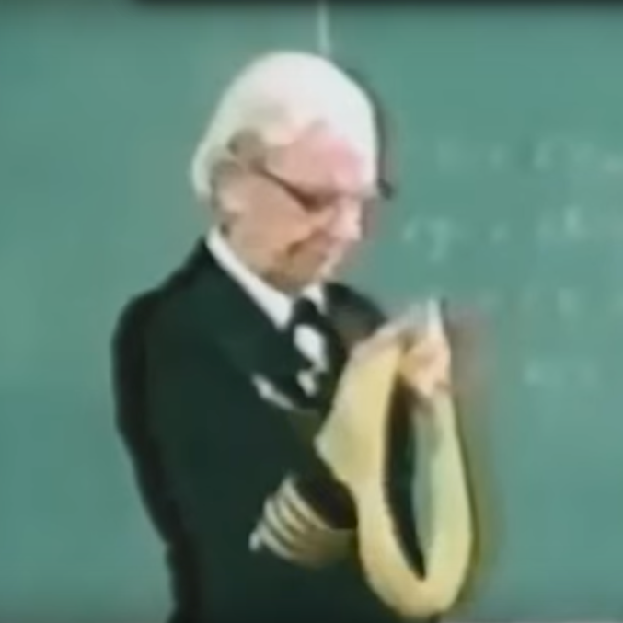
MICROSECOND
GRACE HOPPER
GOLD – THE COLOR OF GRACE HOPPER’S MICROSECOND
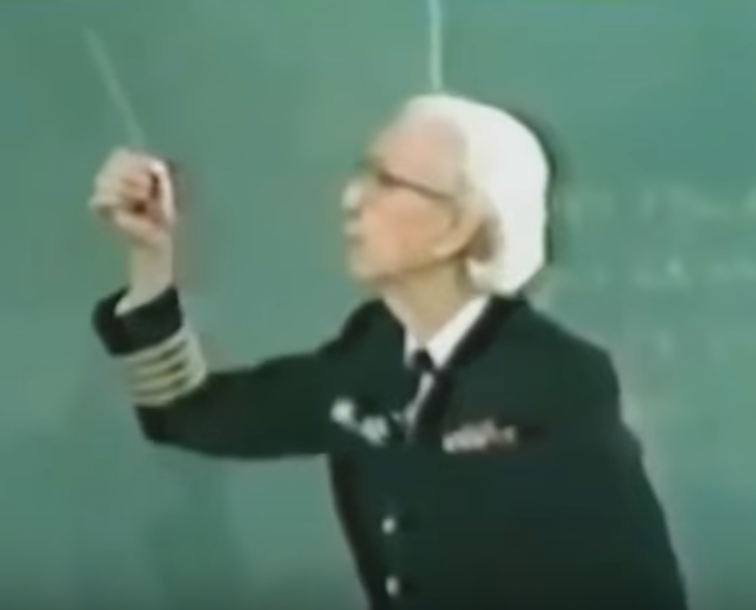
NANOSECOND
SILVER – THE COLOR OF GRACE HOPPER’S NANOSECOND

OPENING RITUAL
CHAPLAIN: Opening Prayer

REGENT: To perpetuate the memory and spirit of the men and women who achieved American Independence; to promote an enlightened public opinion; and to foster true patriotism and love of country. These are the objects of our National Society, Daughters of the American Revolution.

CHAPLAIN:"...keep that which is committed to thy trust..."
(1 Timothy 6:20)

RESPONSE:"...YEA, I HAVE A GOODLY HERITAGE."
(Psalm 16:6)

CHAPLAIN:"...thou shalt remember all the way which the Lord thy God led thee..."
(Deuteronomy 8:2)

RESPONSE:"...BLESSED IS THE NATION WHOSE GOD IS THE LORD..."
(Psalm 33:12)

THE PLEDGE OF ALLEGIANCE TO THE FLAG OF
THE UNITED STATES OF AMERICA
(in unison)
I pledge allegiance to the Flag of the United States of America and to the Republic for which it stands, one Nation under God, indivisible, with liberty and justice for all.
Francis Bellamy

THE AMERICAN'S CREED

(in unison)
I believe in the United States of America as a government of the people, by the people, for the people; whose just powers are derived from the consent of the governed, a democracy in a republic, a sovereign Nation of many sovereign States; a perfect union, one and inseparable, established upon those principles of freedom, equality, justice, and humanity for which American patriots sacrificed their lives and fortunes.
I therefore believe it is my duty to my country to love it, to support its Constitution, to obey its laws, to respect its flag and to defend it against all enemies.
William Tyler Page

CHAPTER REGENTS

Michelle Caputy | 2015-2017
Grace Fischetti | 2017-2019
Michelle Reynolds | 2019-Current

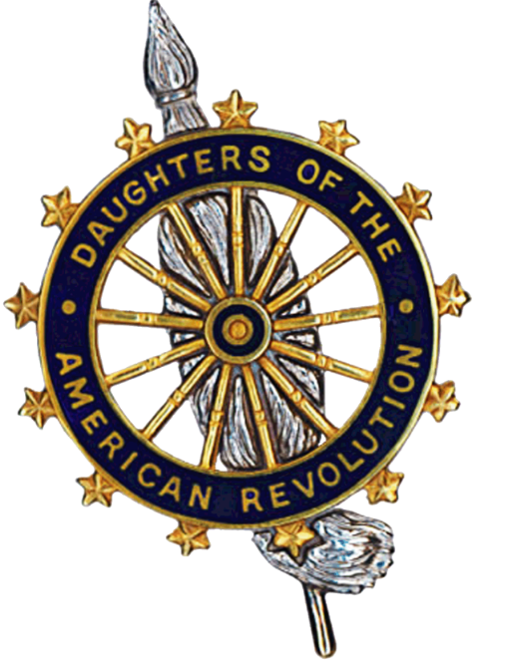
THE FOUR FOUNDERS
1890
Mary Desha, Mary S. Lockwood, Ellen Walworth, Eugenia Washington
"GOD, HOME AND COUNTRY"


PRESIDENT GENERAL
2019-2022
Denise Van Buren
"Rise and Shine for America"


VIRGINIA STATE REGENT
2019-2022
LeAnn Fetherolf Turbyfill
“Enlighten, Enliven, Engage: Shine the Light of DAR!”

VIRGINIA DISTRICT VIII DIRECTOR
2019-2022
Margaret Stromberg
Theme: “Shining with Infinite Possibilities”

2019-2020 GENERAL INFORMATION:

LEVEL | ADDRESS | USERNAME/PASSWORD
NATIONAL | DAR.org/members | name,  chapter, and national number
STATE | virginiadar.org/members | ShineTheLight
DISTRICT | virginiadar8.org | ___
CHAPTER | mariamitchellchapterdar.org | ___

2019-2020 LEADERSHIP INFORMATION:

LEVEL | NAME | ADDRESS
NATIONAL | NSDAR HEADQUARTERS | Administration Building  1776 D Street NW  Washington, DC 20006-5303  202-628-1776
STATE | LeAnn Turbyfill | LeAnnT1776dar@gmail.com
DISTRICT | Margaret Stromberg | mmstromberg66@gmail.com
CHAPTER | Michelle Reynolds | mariamitchellchapterdar@gmail.com

2020-2021 POSITIONS HELD BY CHAPTER MEMBERS

LEVEL | TYPE | TITLE | MEMBER
NATIONAL | ___ | ___ | ___
STATE | Outstanding Junior Contest | State Vice Chair | Michelle Caputy
STATE | The Flag of the USA | State Chair | Courtney Dozier
DISTRICT | ___ | ___ | ___
CHAPTER | OFFICER | REGENT | Michelle Reynolds
CHAPTER | OFFICER | FIRST VICE REGENT | Courtney Dosier
CHAPTER | OFFICER | CHAPLIN | Sarah Corey
CHAPTER | OFFICER | RECORDING SECRETARY | Grace Fischetti
CHAPTER | OFFICER | CORRESPONDING SECRETARY | Rachelle Janke
CHAPTER | OFFICER | TREASURER | Kristyn Ream
CHAPTER | OFFICER | REGISTRAR | Melissa Riesco
CHAPTER | OFFICER | HISTORIAN | Martina Caputy
CHAPTER | OFFICER | LIBRARIAN | Laura Liberman

2020-2021 POSITIONS HELD BY CHAPTER MEMBERS CONTINUED

LEVEL | TYPE | MEMBER | TITLE
CHAPTER | CHAIRMAN | Kelley Cappellini | American Heritage
CHAPTER | CHAIRMAN | Kelley Cappellini | DAR Project Patriot
CHAPTER | CHAIRMAN | Michelle Caputy | DAR Service for Veterans
CHAPTER | CHAIRMAN | Michelle Caputy | Community Service Awards
CHAPTER | CHAIRMAN | Rachelle Janke | Children of the American Revolution
CHAPTER | CHAIRMAN | Rachelle Janke | DAR Schools
CHAPTER | CHAIRMAN | Melissa Riesco | Scholarship
CHAPTER | CHAIRMAN | Melissa Riesco | Dar Museum
CHAPTER | CHAIRMAN | Courtney Dozier | The Flag of the USA
CHAPTER | CHAIRMAN | Courtney Dozier | Americanism
CHAPTER | CHAIRMAN | Laura Lieberman | Historical Preservation
CHAPTER | CHAIRMAN | Laura Lieberman | Sunshine
CHAPTER | CHAIRMAN | Sarah Corey  Kristyn Ream | National Defense
CHAPTER | CHAIRMAN | Grace Fischetti | Membership
CHAPTER | CHAIRMAN | Grace Fischetti | Junior Membership
CHAPTER | CHAIRMAN | Grace Fischetti | Commemorative Events
CHAPTER | CHAIRMAN | Grace Fischetti | Conservation
CHAPTER | CHAIRMAN | Grace Fischetti | Women's Issues
CHAPTER | CHAIRMAN | Grace Fischetti | VIS
CHAPTER | CHAIRMAN | Grace Fischetti | Protocol
CHAPTER | CHAIRMAN | Grace Fischetti | Insignia

2020-21 SERVICE PROJECTS WITH CHAPTER INVOLVEMENT:

COMMITTEE | CAUSE | DESCRIPTION
Conservation | Recycling Plastic | Pairing with Fairfax Chapter, we collect plastic bags, weigh them and return them to participating grocery stores. Once a weight limit is reached a bench will be commissioned to honor the effort.
Conservation | Cemetery Clean-up | We clean up the Clark-Hunt Cemetery
Conservation | Sunshine Gardens | We maintain and create gardens with pollinator plants to help save the bees
DAR Schools | Boxtops for Education | We will collect Boxtops for education and submit them for DAR schools
Service for Veterans | CakePops for Veterans | We make care packages with homemade cakepops for veterans at the Walter Reed Fisher House
Service for Veterans | Wreaths Across America | We lay and clean up wreaths on veterans’ graves for the winter season
Service for Veterans | Clothing Drive | We donate clothing to veterans and their families
Women’s Issues | Cell phone/Gift Card Drive | We donate cell phones and gift cards to women’s shelters

2020-2021 EVENTS WITH CHAPTER INVOLVEMENT:

LEVEL | DATE | NAME | LOCATION
National | 6/30-7/4 | Continental Congress | Washington, DC
State | 9/19 | Fall Forum | Virtual
State | 3/12-14 | State Conference | Richmond, VA
State | 7/1 | Virginia Luncheon | Washington, DC
District | 8/18 | District VIII Meeting | Virtual
Chapter | 9/10 | Back to School Meeting | Virtual
Chapter | 9/19 | The ABC’s of DAR Tea | Virtual
Chapter | 10/8 | Women’s Issues Meeting | Virtual
Chapter | 10/11 | Closet Cleanout National Day of Service | Virtual
Chapter | 10/31 | Spooky Movie Tea | Virtual
Chapter | 11/12 | 400th Anniversary of the Mayflower Chapter Meeting | Virtual
Chapter | 11/28 | I’m Thankful for....Tea | Virtual
Chapter | 12/10 | CAR Chapter Meeting | Virtual
Chapter | 12/19 | Festive Fun Tea | Virtual
Chapter | 1/2 | Shiny New Year Tea | Virtual
Chapter | 1/14 | How are we doing? Meeting | Virtual
Chapter | 2/11 | Black History Month Chapter Meeting | Virtual
Chapter | 2/27 | Who’s that Hero Tea | Virtual
Chapter | 3/11 | Women’s History  Chapter Meeting | Virtual
Chapter | 3/20 | Mother’s Appreciation Tea | Virtual
Chapter | 4/8 | Women in the Workplace Chapter Meeting | Virtual
Chapter | 4/24 | Single Lady Appreciation Tea | Virtual
Chapter | 5/13 | End of Year Chapter Meeting | Virtual
Chapter | 5/28 | Chapter Anniversary Party | Virtual

2019-2020 CHAPTER MEMBER CONTACT INFORMATION PAGE 1 OF 2:

Cappellini, Kelley Annette Riles (904) 868-4704 (cell)
13885 Piedmont Vista Dr Birthday: 8 Jul
Haymarket, VA 20169-3219 Admitted: 6 Feb 2010
rkcappellini@gmail.com
880163 ISHAM THRIFT, NC, PS

Caputy, Martina Elizabeth (202) 986-2981
2632 Woodley Pl NW Birthday: 9 Sep
Washington, DC 20008-1523 Admitted: 3 Oct 2009
martina.e.caputy@gmail.com
876653 STEPHEN PUTNAM, NH, PS

Corey, Sarah Michelle 210-317-1364
901 N Pollard St Apt 1009 Birthday: 22 May
Arlington, VA 22203-4092 Admitted: 6 Dec 2003
smcorey522@yahoo.com
823870 JOHN LARGE, NJ, PS PVT

Dozier, Courtney Elizabeth Clark (571) 235-6717
2230 Fairfax Dr Apt 812 Birthday: 6 Jul
Arlington, VA 22201-6624 Admitted: 5 Nov 2015
CortiZmo@aol.com
950513 JOSEPH LIGON, SR, VA, CAPT

Fischetti, Grace Rosina (240) 832-1489
815 Pershing Dr, Apt 435 Birthday: 2 Nov
Silver Spring, MD 20910 Admitted: 5 Jun 2016
grace.r.fischetti@gmail.com
957898 SAMUEL COX, MA, CPL

Fischetti, Linda Friauf (301) 252-3455
1509 Moffet Rd Birthday: 20 Mar
Silver Spring, MD 20903-1934 Admitted: 5 Jun 2016
lindaFischetti@gmail.com
957897 SAMUEL COX, MA, CPL

2020-21 CHAPTER MEMBER CONTACT INFORMATION PAGE 2 OF 2:

Janke, Rachelle Marie (571) 263-3741
12780 Tadworth Pl Apt 202 Birthday: 9 Jul
Woodbridge, VA 22193-4971 Admitted: 9 Apr 2011
historygirlly@gmail.com
892368 THOMAS MEREDITH, PA, PVT

Lieberman, Laura Anne (770) 362-3083
4001 9th St N Apt 1308 Birthday: 6 Oct
Arlington, VA 22203-1966 Admitted: 5 Jul 2016
laura.a.lieberman@gmail.com
958963 JOHN LANGFORD, SC, PS

McIntyre, Nicole Frances (770) 940-7426
4324 Perth Trce NE Birthday: 29 Dec
Roswell, GA 30075-2645 Admitted: 5 Apr 2015
942012 STEPHEN PUTNAM, NH, PS

Moser, Ann Wiley (703) 200-0339
901 N Monroe St Apt 502 Birthday: 16 May
Arlington, VA 22201-2355 Admitted: 8 Oct 2005
annwmoser@live.com
837316 FRANCIS BARRETT, VA, SGT

Ream, Kristyn Elise Admire (630) 975-1228
4424 Chase Park Ct Birthday: 28 Dec
Annandale, VA 22003-5728 Admitted: 5 Jun 2016
kristyn.ream@gmail.com
957983 GEORGE ADMIRE, NC, CS PS

Reynolds, Michelle Perry (202) 986-2981, (703) 867-5012
2632 Woodley Pl NW Birthday: 20 Aug
Washington, DC 20008-1523 Admitted: 11 Dec 2004
mcaputy@gmail.com
832009 STEPHEN PUTNAM, NH, PS

Riesco, Melissa Keller Schwolow 703-273-2723
4904 Tydfil Ct Birthday: 23 Mar
Fairfax, VA 22030-5410 Admitted: 9 Dec 1982
mriesco@lumark.com
668630 GEORGE KELLER, SR, VA, PS

